Retail Sales Data Agent on Databricks
Student Name:
Angel Dikobo
Student Number:
2805001540
Course:
Data Analytics with SQL
Submission Date:
24 May 2026
Introduction & Objective
This project focuses on building a Retail Sales Data Agent using Databricks. The purpose of the project is to enable business users, such as managers and decision makers to interact with retail sales data using simple, natural language questions instead of writing technical queries.
The data agent is designed to analyse and provide insights into sales performance, customer behaviour, and product trends. By using real transaction data, the agent helps users quickly understand business performance and make informed decisions.
The objective of this project is to:
- Upload and prepare a retail sales dataset in Databricks
- Create a functional data agent connected to the dataset
- Develop clear and original agent instructions
- Test the agent using business-related questions
- Validate responses using SQL queries
- Present the entire process in a structured and professional format
Dataset Description
The dataset used in this project is named Retail Sales Data. It contains records of retail transactions, including customer details, product categories, and sales information, transaction ID, date, customer ID, gender and age.
Below are the screenshots of the process
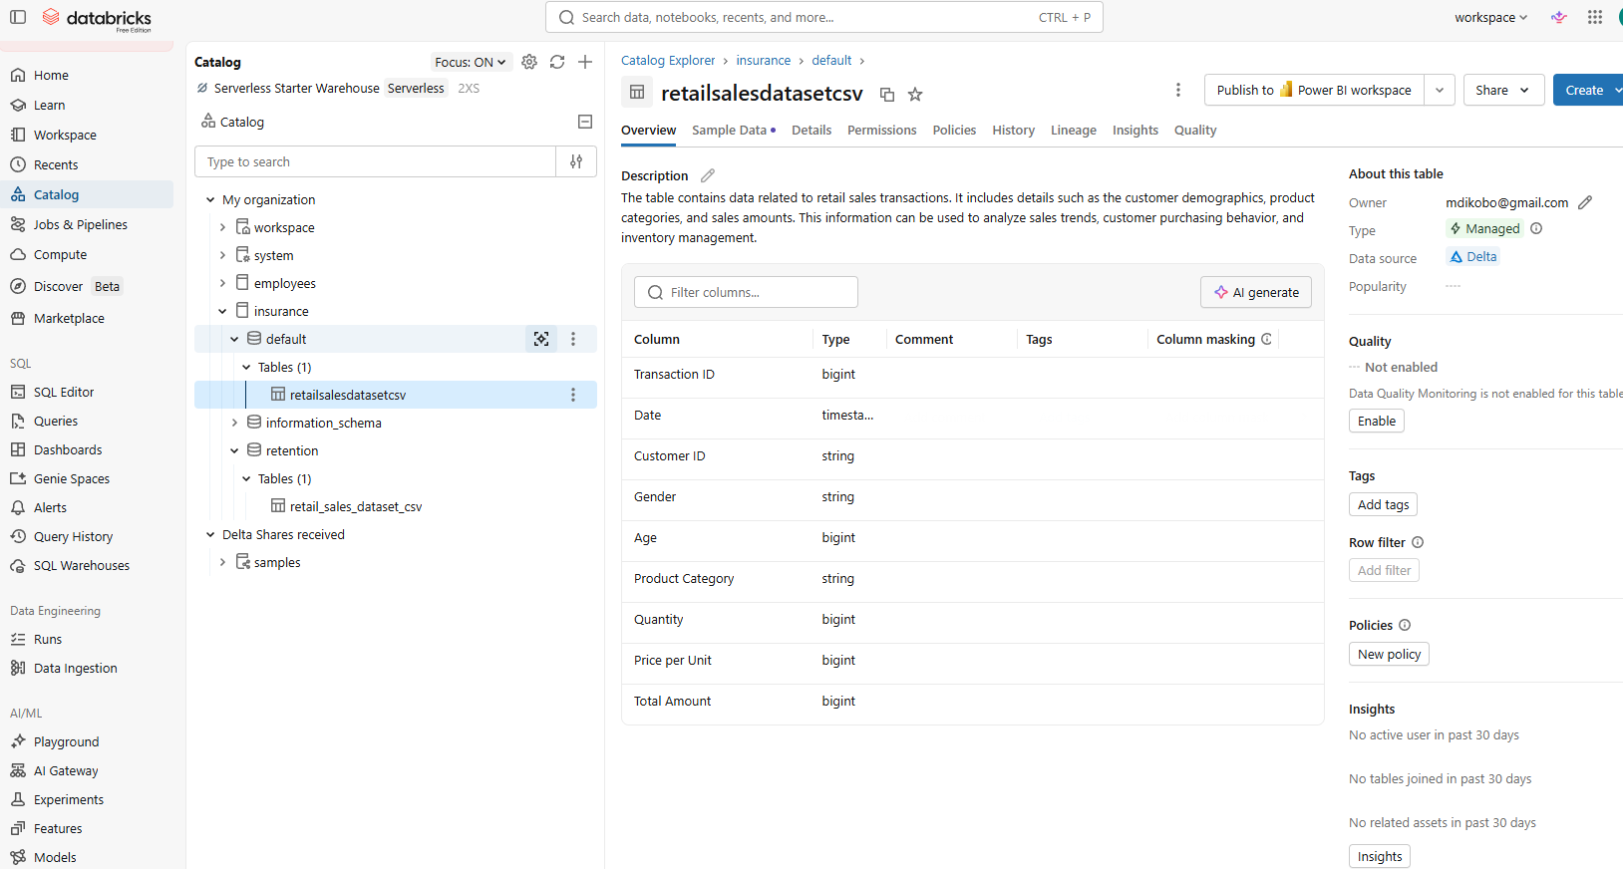
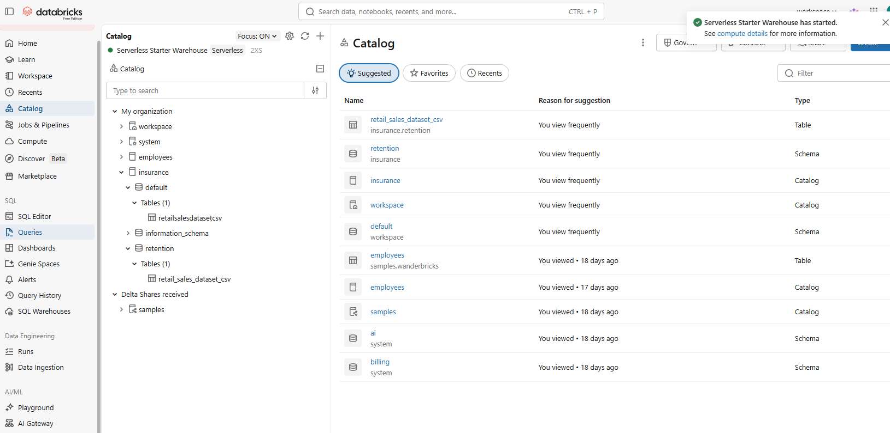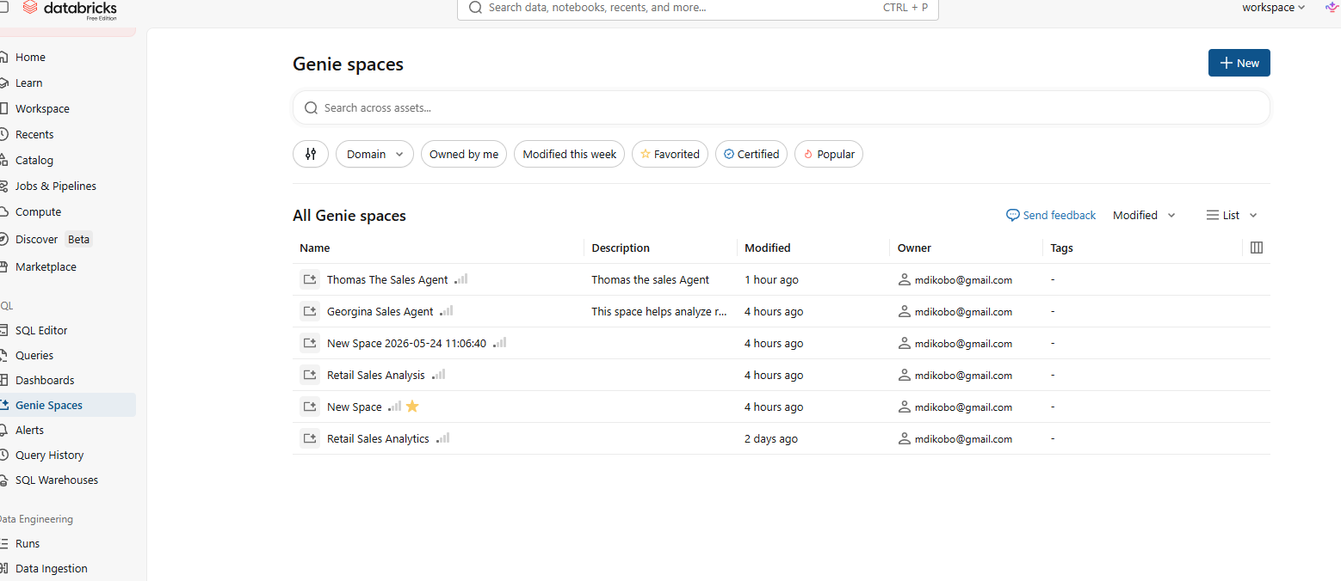

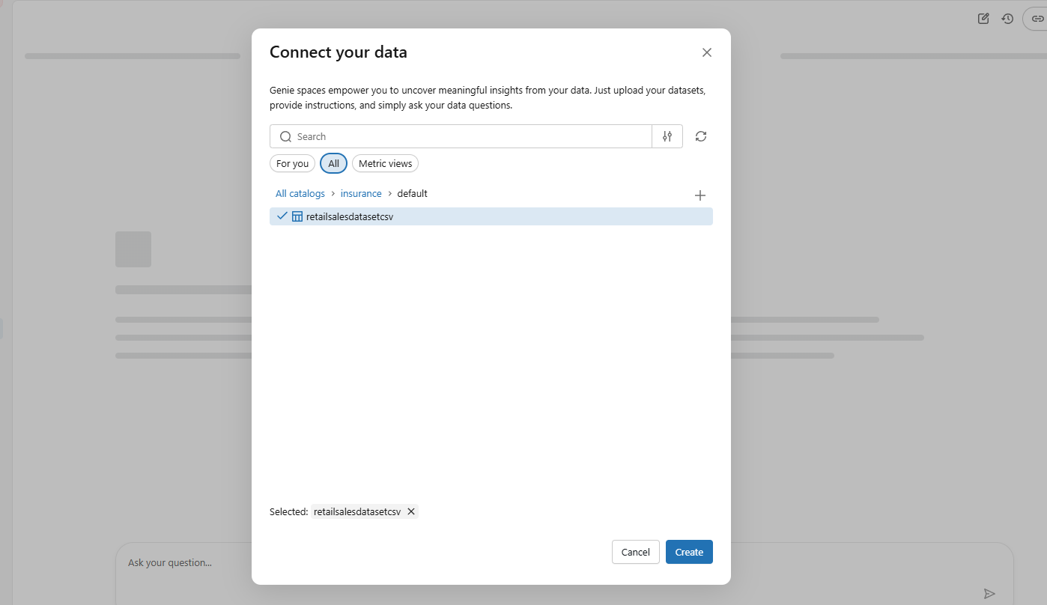
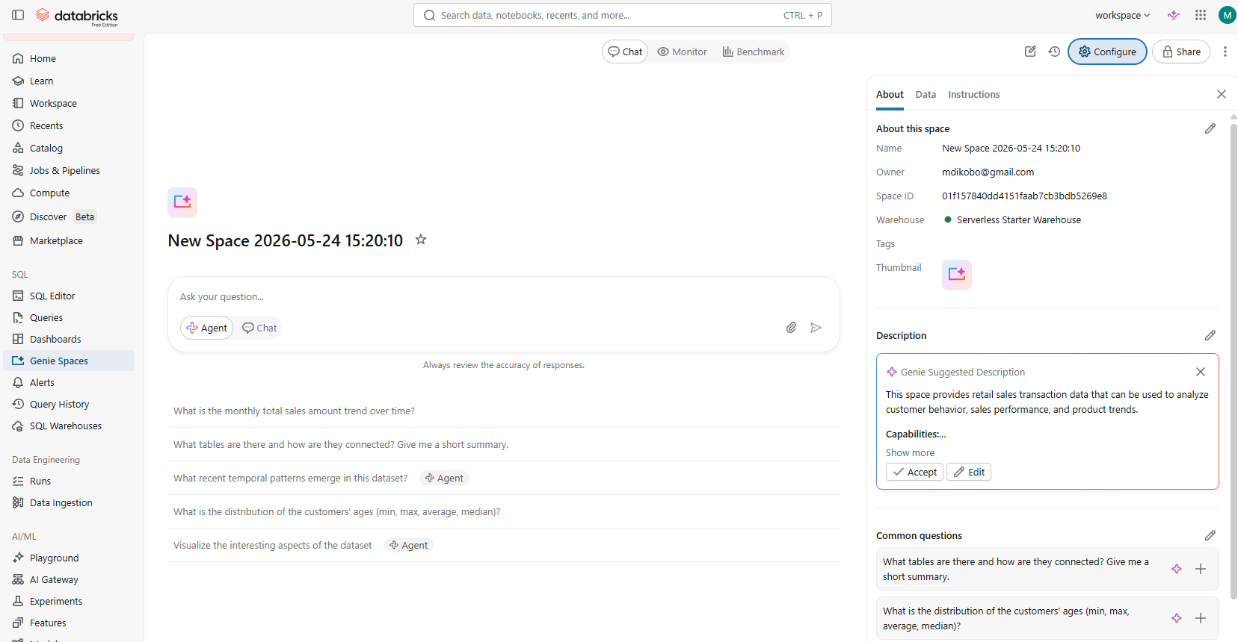
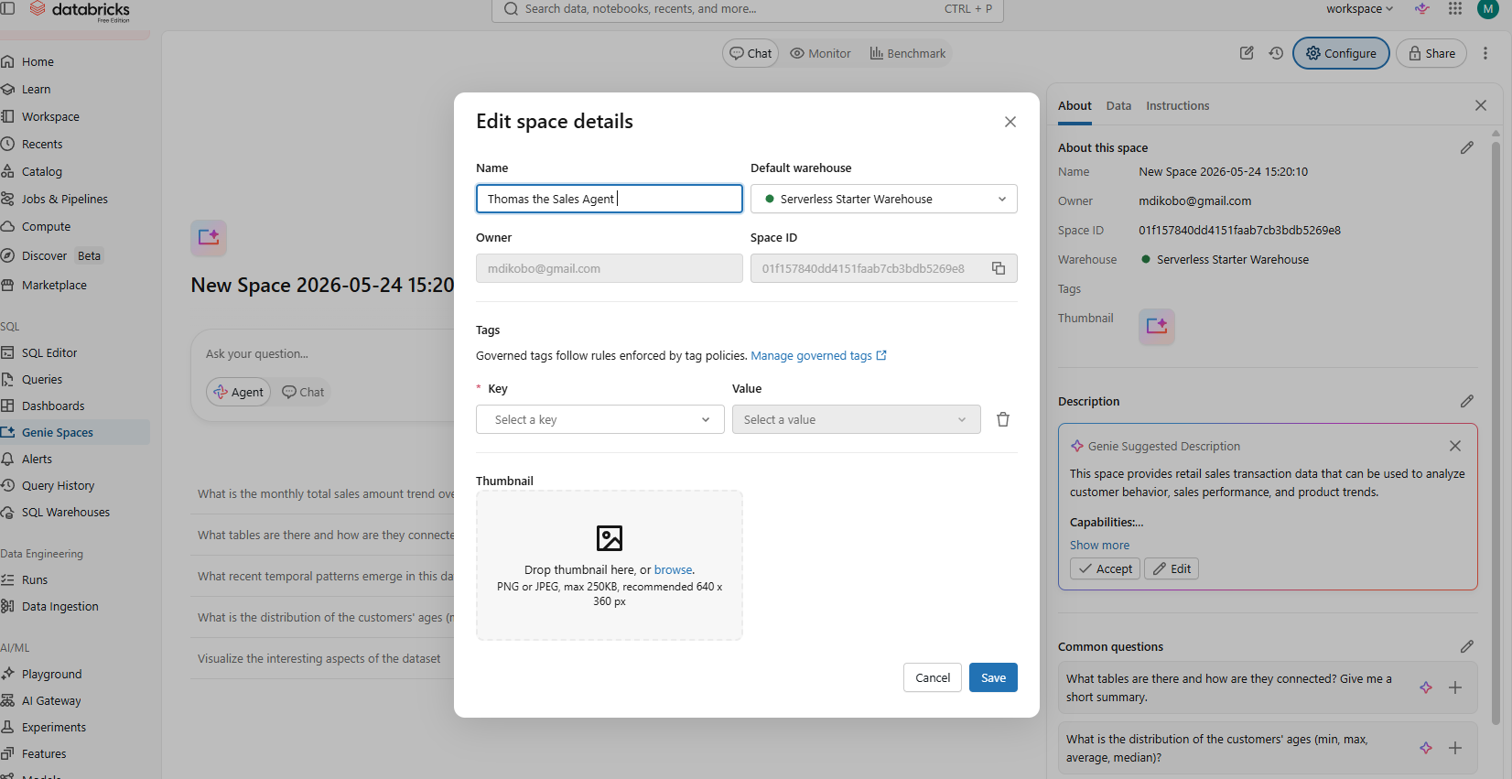
Write up my own instructions to Thomas when answering question in simple business language
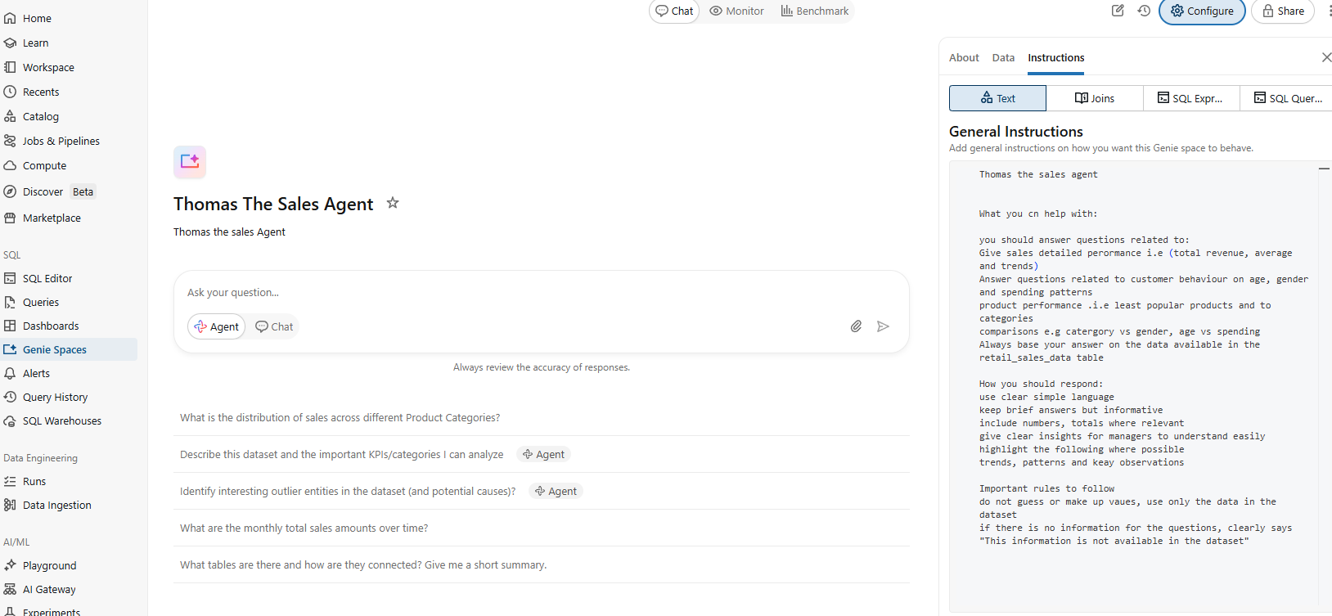
My instructions to Thomas the sales agent
Thomas the sales agent, What you can help with:
You should answer questions related to:
Give sales detailed performance i.e. (total revenue, average and trends)
Answer questions related to customer behaviour on age, gender and spending patterns
product performance. i.e. least popular products and to categories
comparisons e.g. category vs gender, age vs spending
Always base your answer on the data available in the retail_sales_data table
How you should respond:
use clear simple language
keep brief answers but informative
include numbers, totals where relevant
give clear insights for managers to understand easily
highlight the following where possible
trends, patterns and key observations
Important rules to follow do not guess or make up values, use only the data in the dataset. If there is no information for the questions, clearly says "This information is not available in the dataset"

What is the total sales review
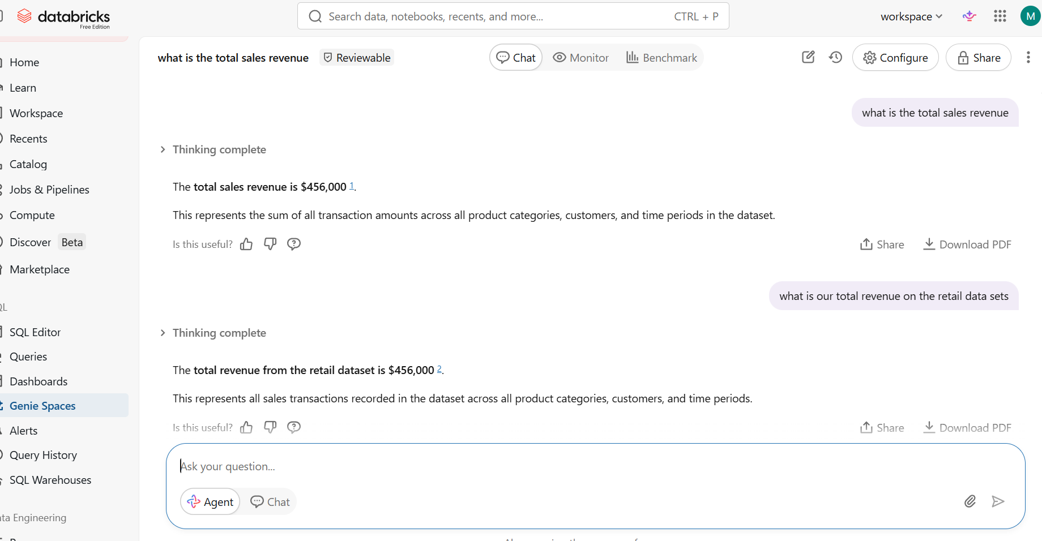
What is our total revenue on the retail data sets
Which product category performs the best
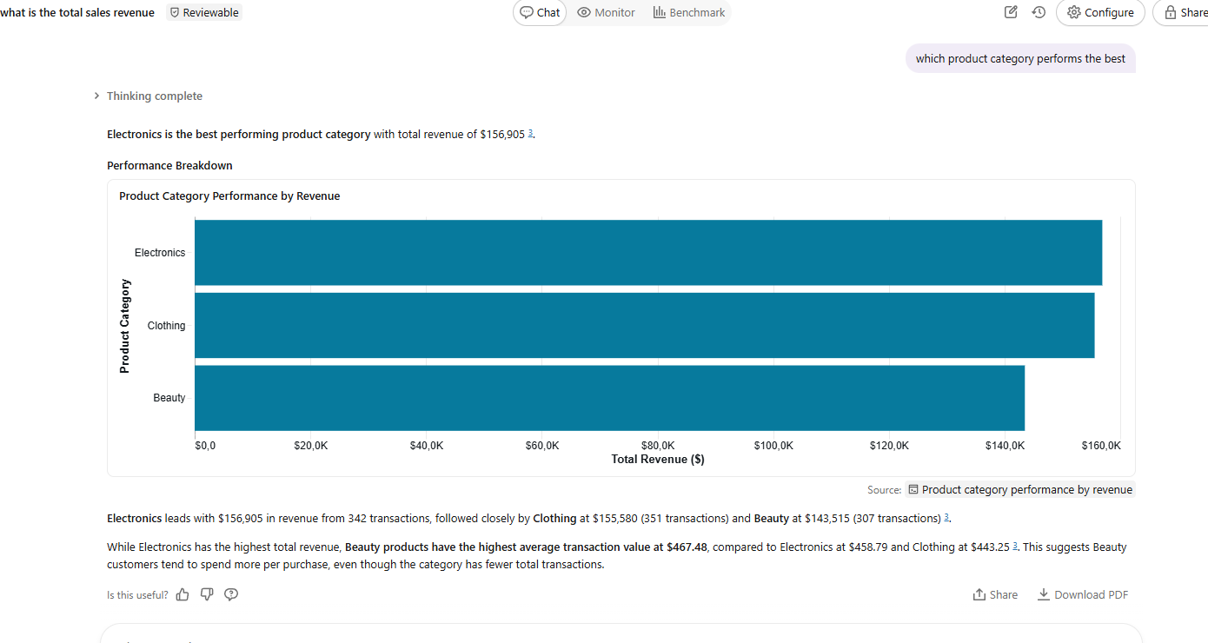
How do sales differ between male and female
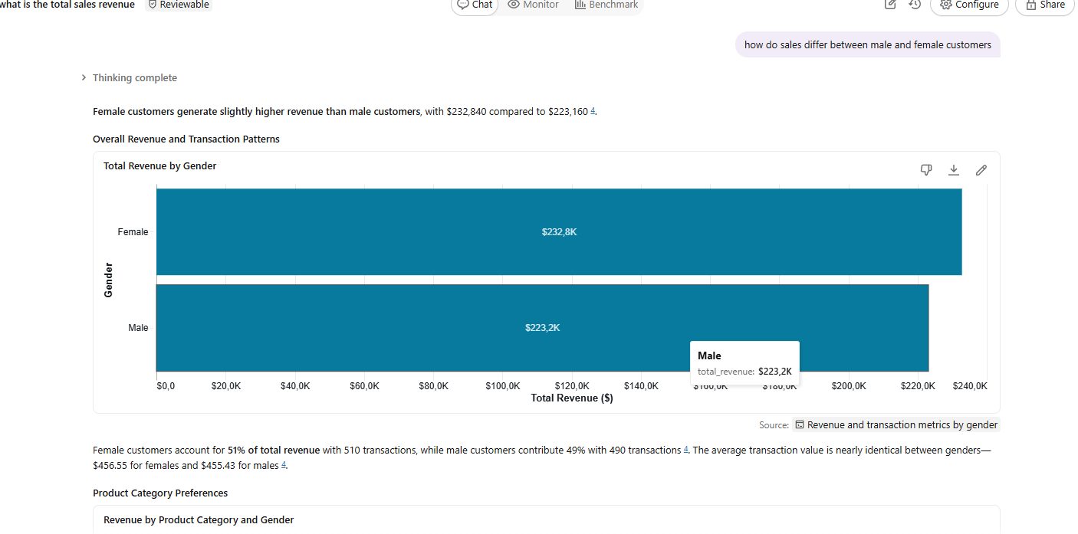
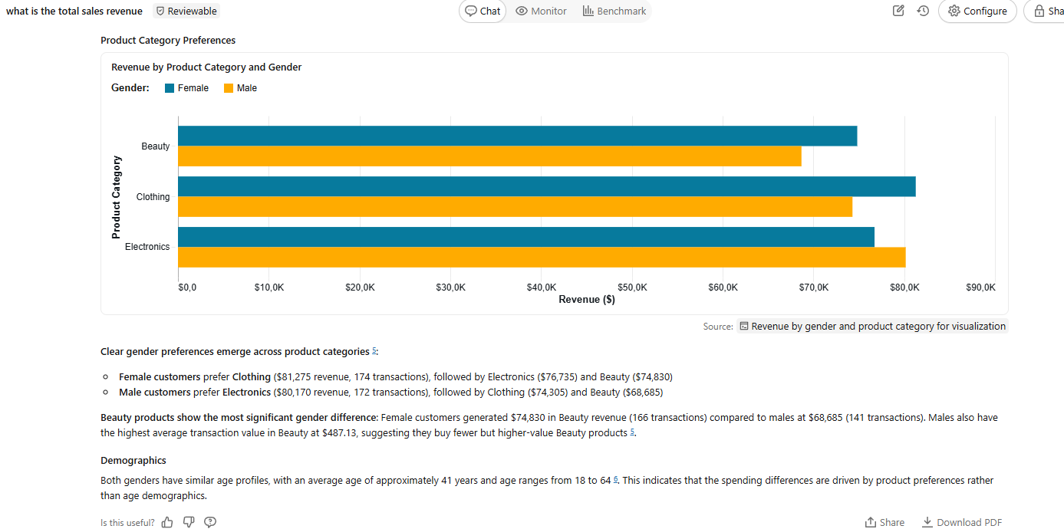
Which month had the highest sales
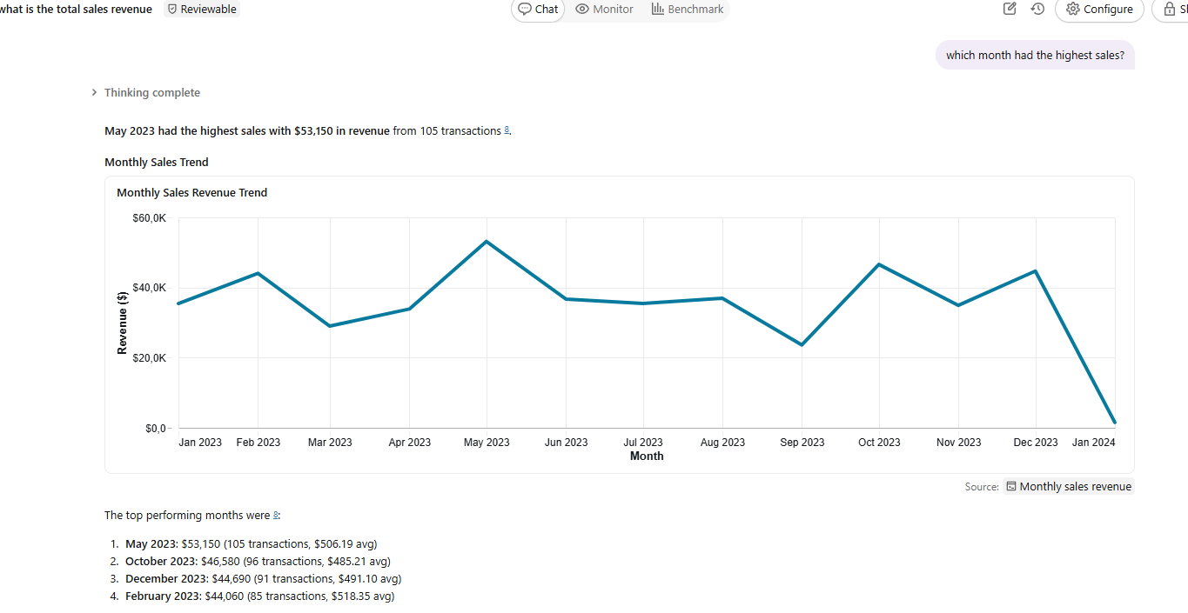
What trends do you see over time
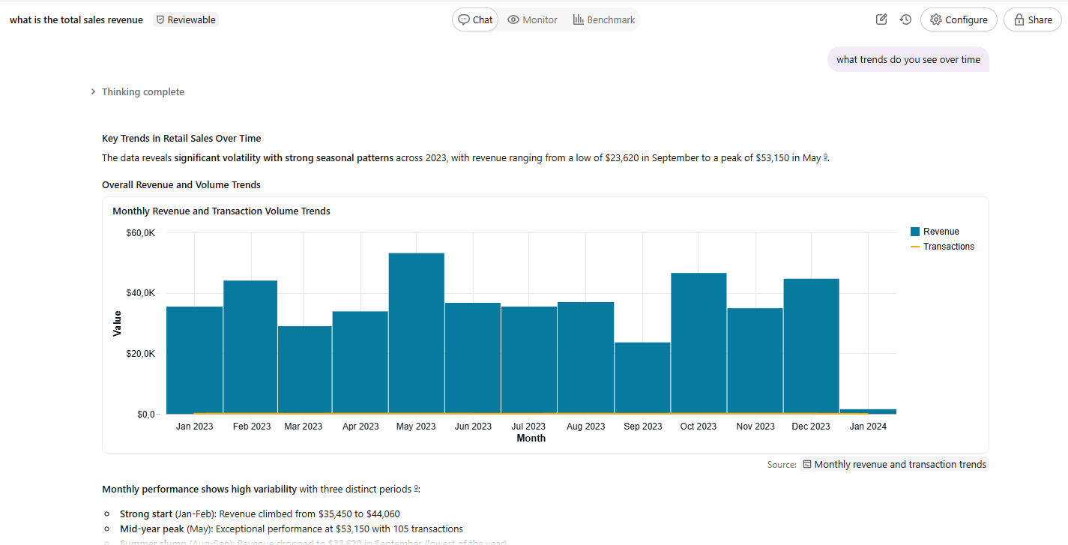
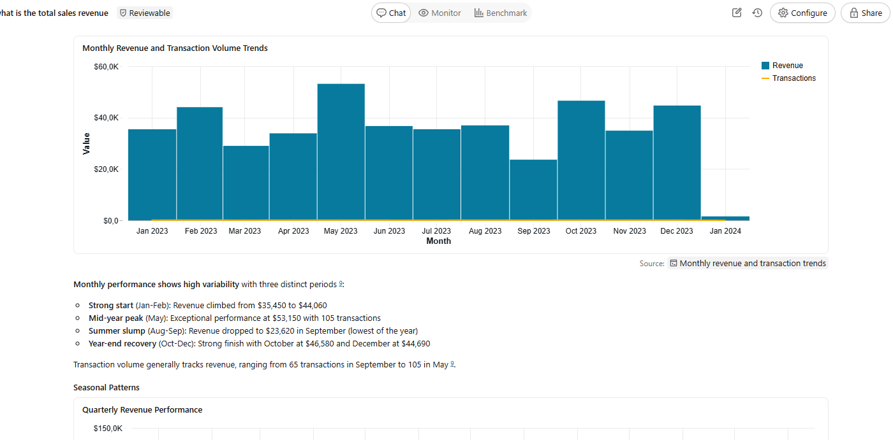
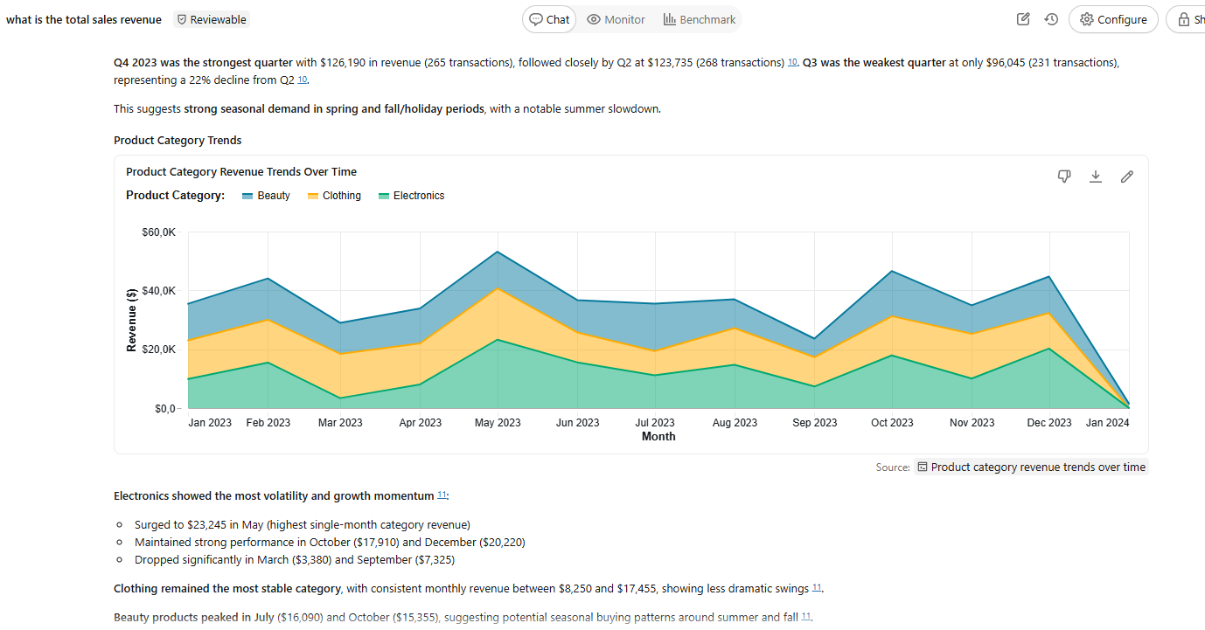
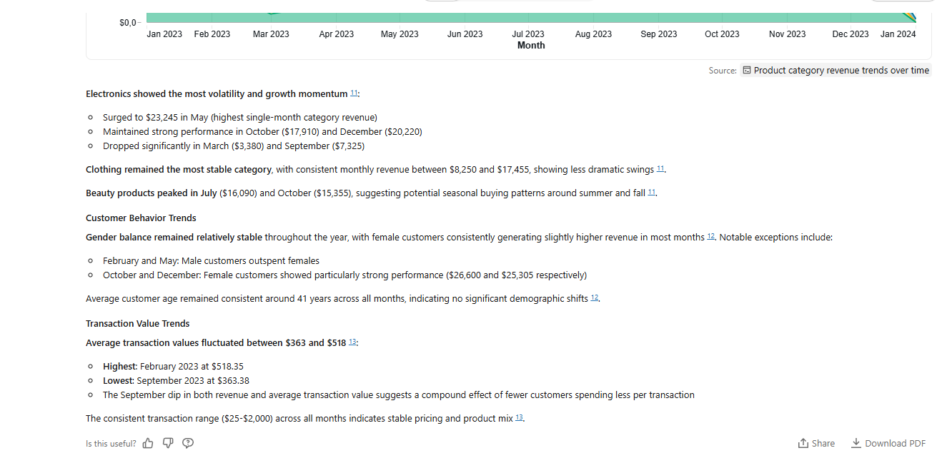
What is the average transaction value
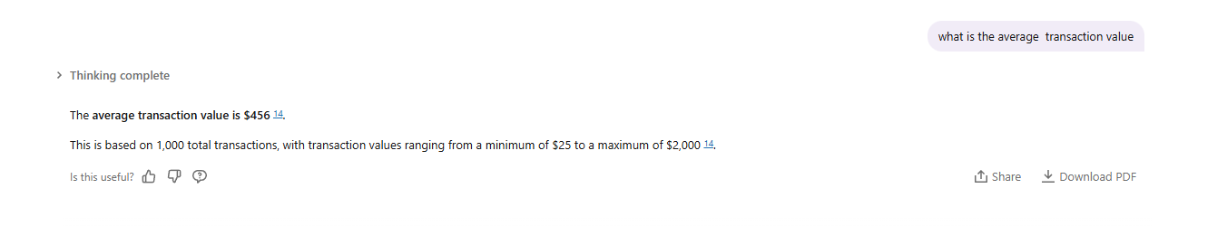Which transaction generated the highest total amount
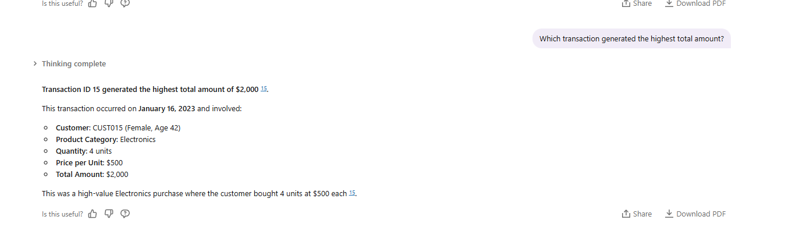
Which day had a highest sales revenue
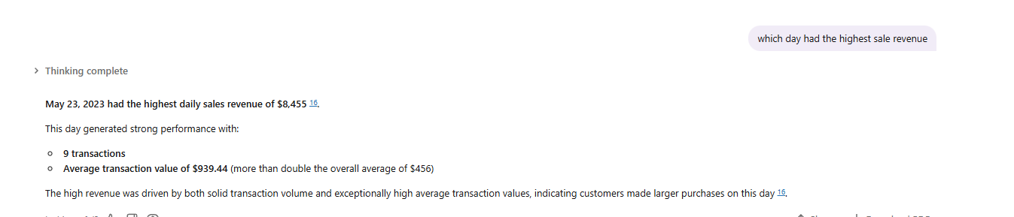
What is the total quantity of the product sold
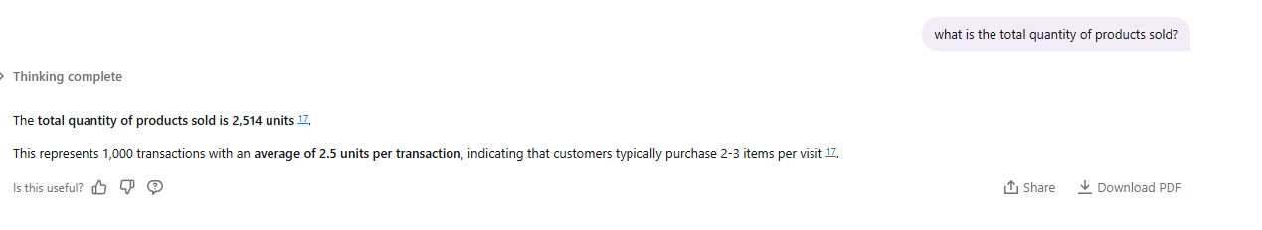
Which product category has the lowest performance
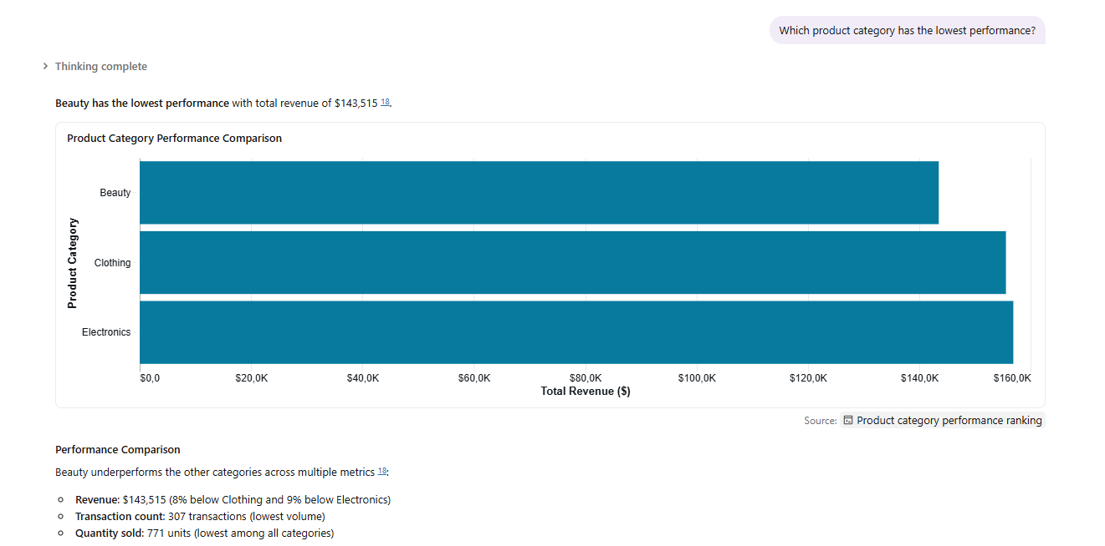

However, Beauty has the highest average transaction value at $467.48, compared to Clothing ($443.25) and Electronics ($458.79) 18. This indicates that while Beauty generates fewer transactions, customers spend more per purchase when they do buy Beauty products.
The lower performance is primarily driven by lower transaction volume rather than lower
spending per transaction.
How do different age groups spend across product category
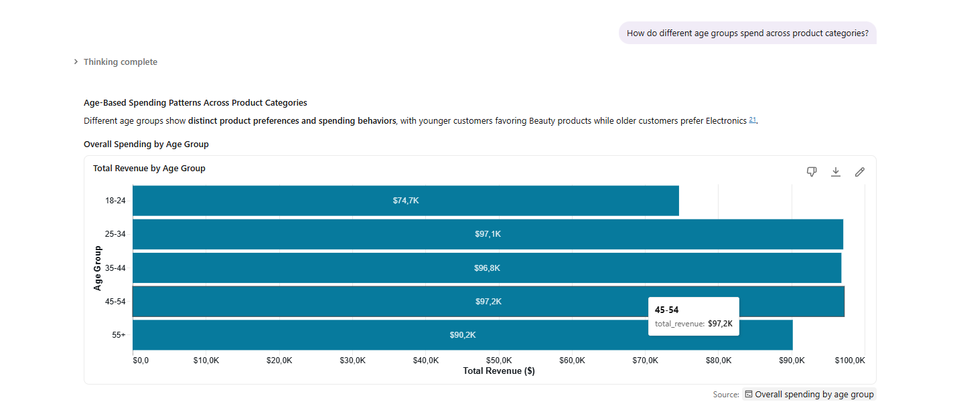
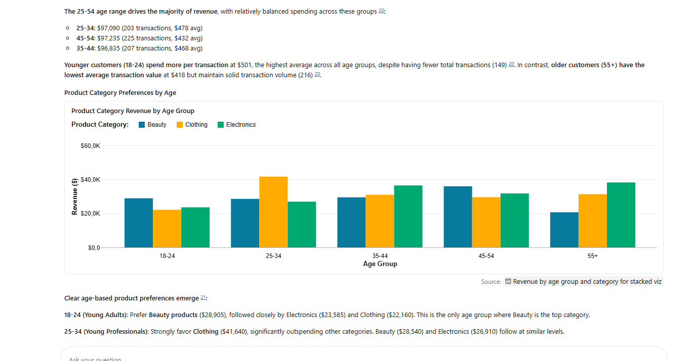
Clear age-based product preferences emerge 21:
18-24 (Young Adults): Prefer Beauty products ($28,905), followed closely by Electronics ($23,585) and Clothing ($22,160). This is the only age group where Beauty is the top category.
25-34 (Young Professionals): Strongly Favor Clothing ($41,640), significantly outspending other categories. Beauty ($28,540) and Electronics ($26,910) follow at similar levels.
35-44 (Mid-Career): Shift to Electronics ($36,460) as the top category, with Clothing ($30,925) and Beauty ($29,450) relatively balanced.
45-54 (Established Professionals): Show the strongest preference for Beauty products ($35,950), the highest Beauty revenue of any age group. Electronics ($31,740) and Clothing ($29,545) trail behind.
55+ (Mature Customers): Heavily Favor Electronics ($38,210), the highest Electronics spending of any age group. Clothing ($31,310) is second, while Beauty drops significantly to $20,670—the lowest Beauty spending across all age groups.
Transaction Value Patterns
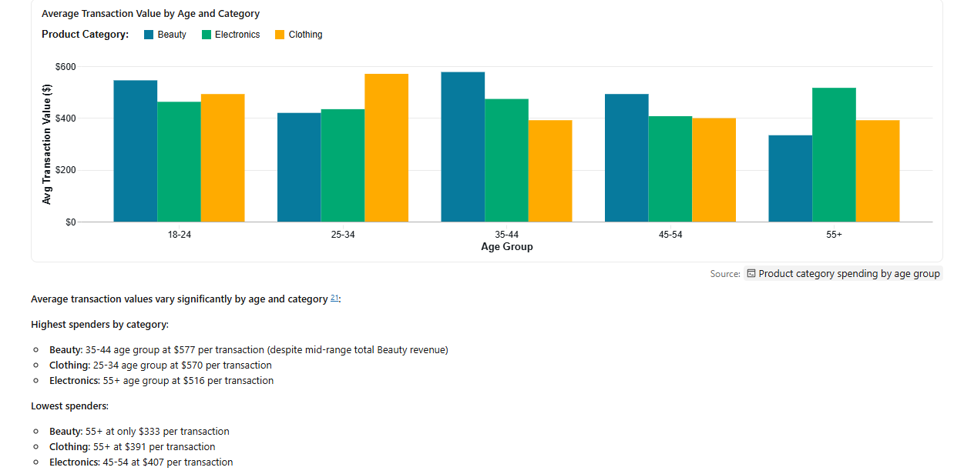
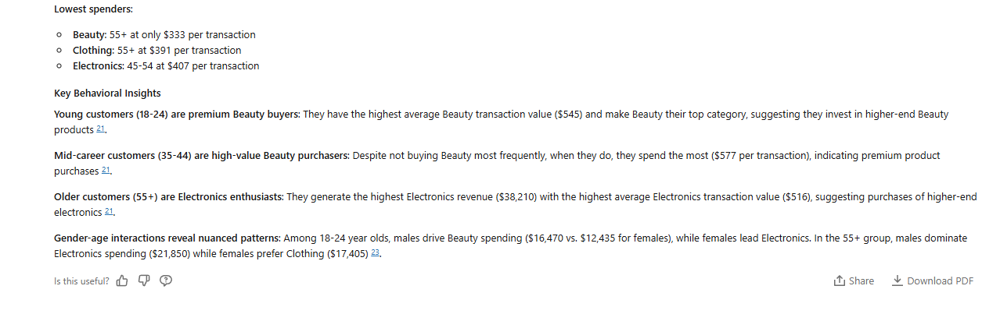
Validating the questions
What is the total Sales revenue generated?
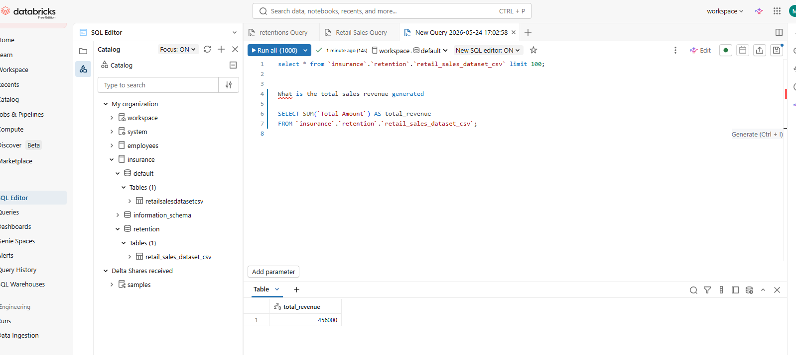

What is the average transaction Value
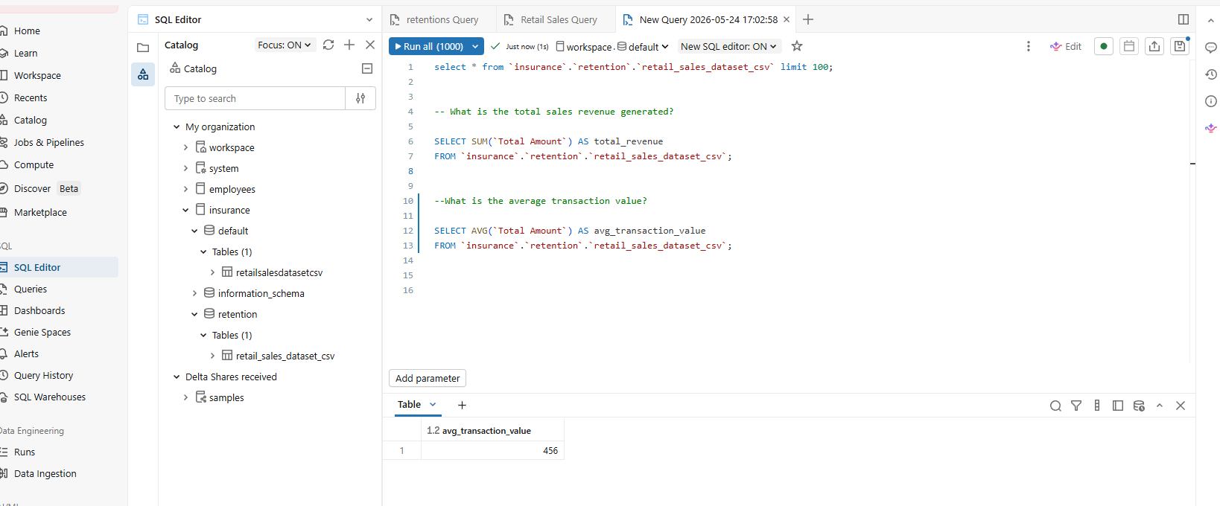
Which customers has spent the most money

Which customers has spent the most money
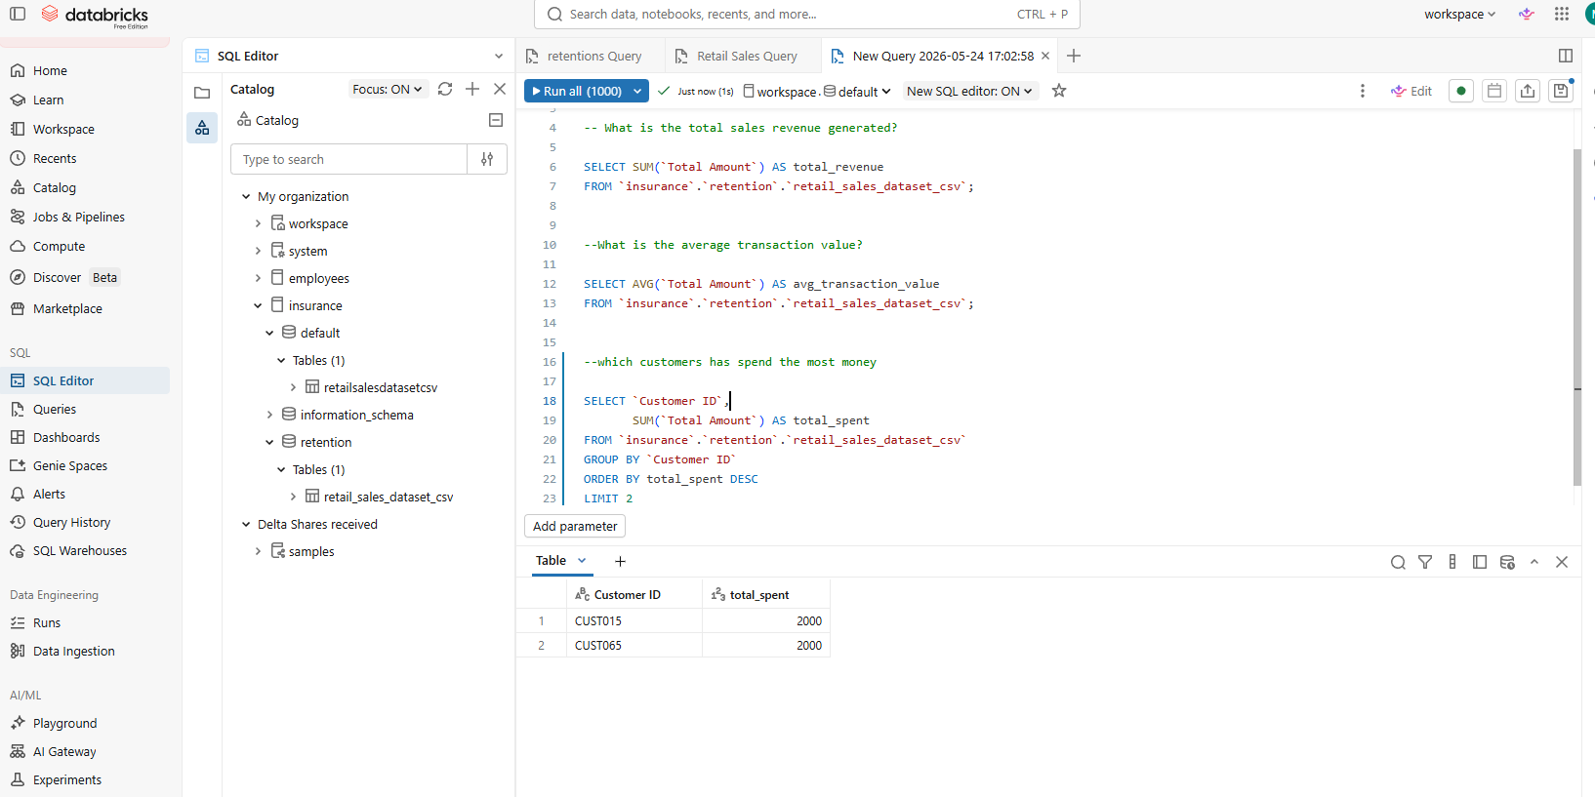

Key insight of what Thomas the sales agent revealed
Firstly, the shop is making steady sales overall, which shows that there are consistent customer activity and demand. Most of the income is not coming from one big transaction, but rather from many smaller purchases.
I also saw that some product categories are doing much better than others. These top categories are bringing in most of the revenue, which means customers clearly prefer certain products. At the same time, there are some categories that are not performing well, which could be a problem for the business.
When looking at customers, I noticed that different groups spend differently. For example, one gender might be spending more than the other, and certain age groups seem to be stronger buyers. This shows that customer behaviour is not the same across all groups.
Another important insight is that sales change over time. Some days or months have higher sales, while others are lower. This suggests that there could be patterns like busy periods and slow periods.
Overall, the data shows clear patterns in sales, customers, and product performance.

BUSINESS RECOMMENDATIONS
Based on the info, I think the business should focus more on the products that are already doing well. These high-performing categories are clearly popular, so increasing stock or promoting them more could help increase sales even further.
For the products that are not performing well, the business should try to understand why. It could be because of pricing, low demand, or lack of awareness. They could try discounts or promotions, and if there is still no improvement, those products might need to be replaced by either a new product or what is selling now.
The business should also use customer information better. Since some age groups or genders spend more, marketing can be targeted specifically to those groups to increase sales.
Another recommendation is to plan better for busy periods. If certain times have higher sales, the business should prepare by having enough stock and staff available.

Conclusion
In this project, I was able to successfully build a Retail Sales Data Agent using Databricks. The agent worked well and was able to answer simple business questions using the data in a clear and understandable way.
One thing that worked well was connecting the dataset to the agent. Once everything was set up correctly, it became easy to ask questions and get quick answers without writing complex queries.
However, there were some challenges along the way. Cleaning the data and making sure all the columns were correct took some time. I also found that writing the agent instructions was not easy, because I had to think carefully about how the agent should behave and respond.
If I were to improve this project, I would spend more time improving the data quality and maybe add more data for deeper analysis. I would also try to make the agent even smarter by adding more detailed instructions.
This project helped me understand how data agents can make analysis easier and help businesses make better decisions.
Github Link
https://github.com/AngelDee24

